INTRODUCTION TO PROGRAMMING
JASVEENA-224001588 PROJECT 1
Learning plan:
Step by step procedure of how I executed the code:
- Made a new document in my device
- Started the code with assigning values to the variables while keeping in mind what to keep inside it.
- Watched some extra videos available online to make sure of how to avoid crashing the code.
- Stored the inputs such as I foot= xyz meters and entered the required texts as well
- Used the if double statement to manage the conditions
- *I was encountering some problems with deference of a null value but I tried quick fixing it and the code worked but I will still need to take guidance from the tutor about it.
- Finally ended my code with all the required statements needed and this is how it looked .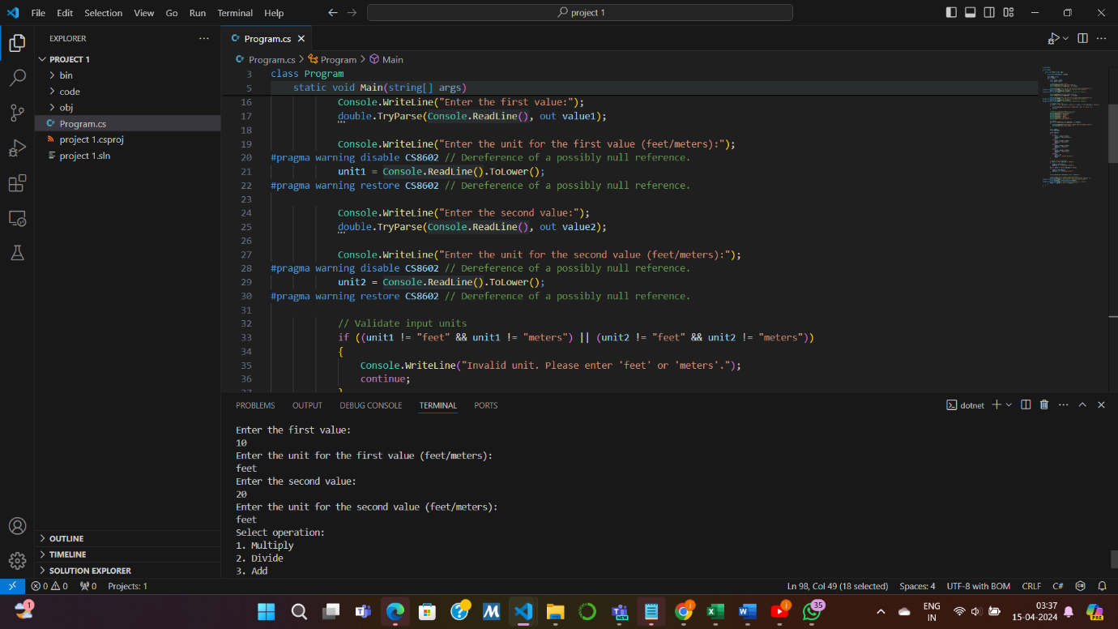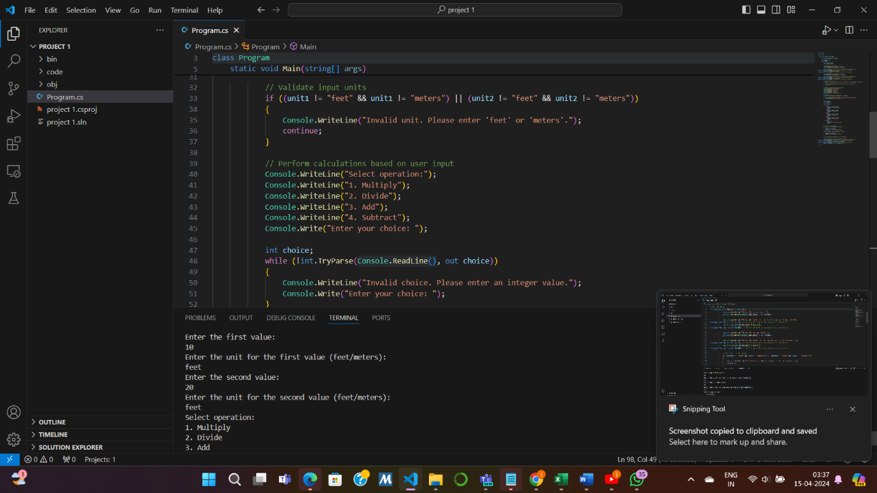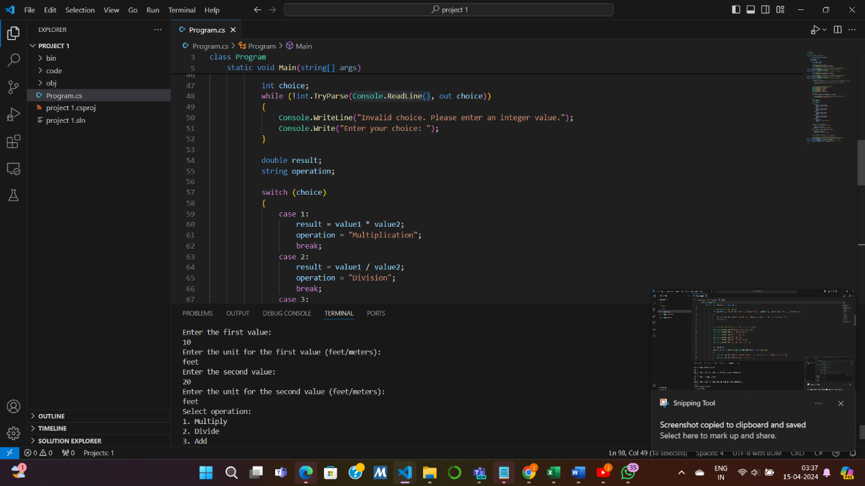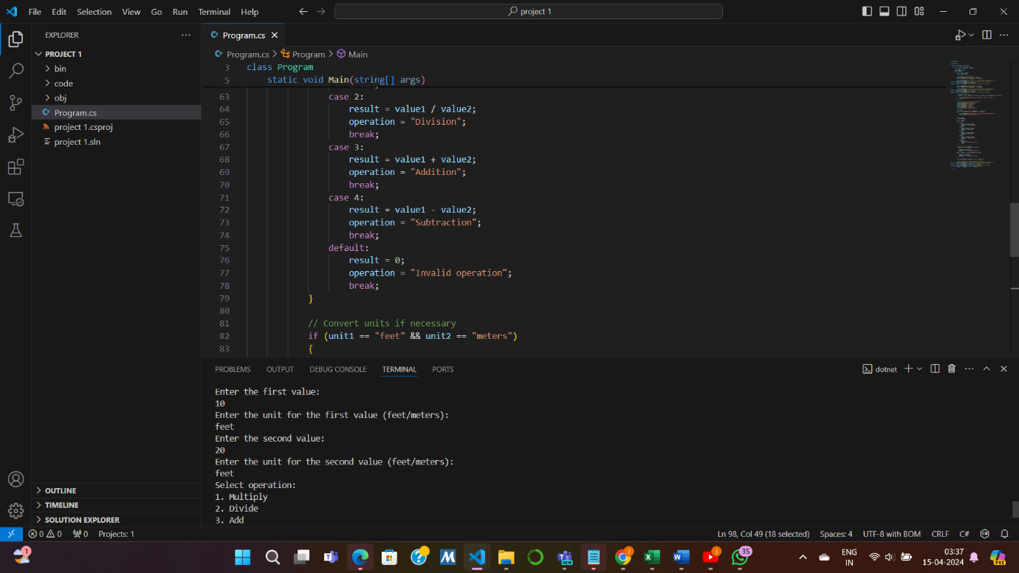

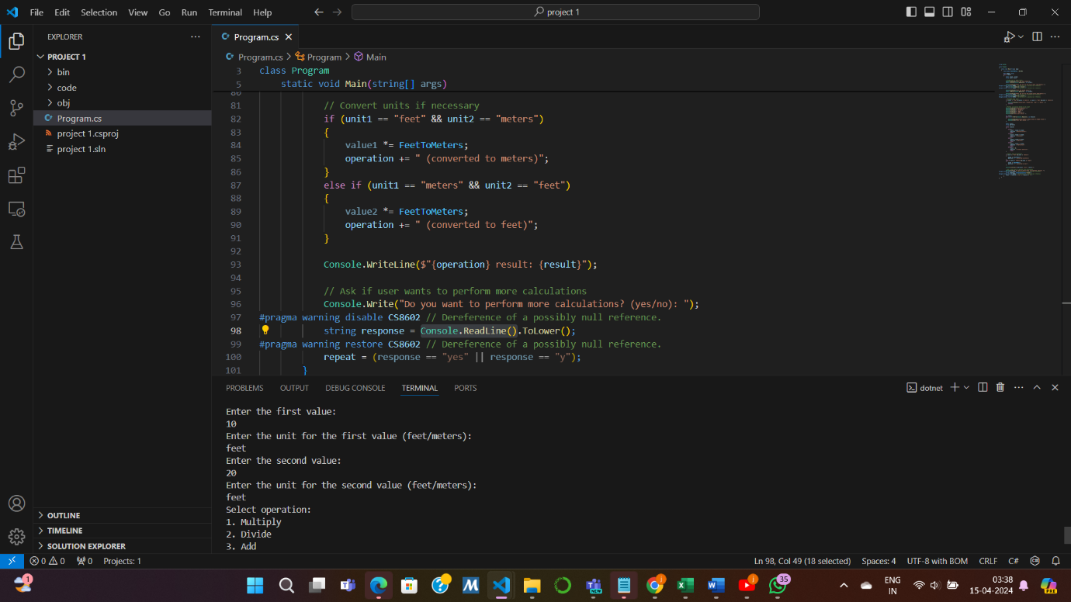

REFLECTIONS

o How do you know you have achieved the learning goals?
I was able to run the code and this time I was quite confident about using the commands and unlike the previous tasks which gave me a hard time running this task went by smoothly. And hereby I am confident to state that I could
- Plan out small algorithms.
- Explain factors that go into making code easy to read.
- Make effective use of my code editor.

o What is the most important thing you learned from this and why?
The most important thing I learned from this task was building algorithms and aligning them together to construct programs.

o How does the content or skills learned here relate to things you already know?
I already know all the basic commands of c# used in vs code which helped me to build the basic algorithm of this task.

using System;

class Program
{
static void Main(string[] args)
{
// Constants for coin values
const int NUM_COIN_TYPES = 6;
const int TWO_DOLLARS = 200;
const int ONE_DOLLAR = 100;
const int FIFTY_CENTS = 50;
const int TWENTY_CENTS = 20;
const int TEN_CENTS = 10;
const int FIVE_CENTS = 5;

// Array of coin values
int[] coinValues = { TWO_DOLLARS, ONE_DOLLAR, FIFTY_CENTS, TWENTY_CENTS, TEN_CENTS, FIVE_CENTS };
// Array of coin texts
string[] coinTexts = { "$2", "$1", "50c", "20c", "10c", "5c" };

// Variable to store user's choice to run the program again
string again;

// Start of do-while loop for repeated program execution
do
{
// Prompt the user for cashier information
Console.WriteLine("Your cashier is Jasveena-224001588");

// Get the cost of the item from the user
int costOfItemDollars = GetIntegerInput("Enter the cost in dollars: ");
int costOfItemCents = GetIntegerInput("Enter the cost in cents: ");
int costOfItem = costOfItemDollars * 100 + costOfItemCents;

// Get the amount paid by the user
int amountPaidDollars = GetIntegerInput("Enter the amount paid in dollars: ");
int amountPaidCents = GetIntegerInput("Enter the amount paid in cents: ");
int amountPaid = amountPaidDollars * 100 + amountPaidCents;

// Check if the amount paid is sufficient
if (amountPaid >= costOfItem)
{
// Calculate the change to give
int changeValue = amountPaid - costOfItem;
Console.WriteLine("Change to give:");

// Loop through each coin type to calculate the change
int i = 0;
do
{
int toGive = changeValue / coinValues[i];
changeValue -= toGive * coinValues[i];
Console.WriteLine($"{coinTexts[i]} coins: {toGive}");
i++;
} while (i < NUM_COIN_TYPES);
}
else
{
// Inform the user about insufficient payment
Console.WriteLine("Insufficient payment. Please provide more.");
}

// Ask the user if they want to run the program again
Console.Write("Do you want to run again? (Y/N): ");
again = Console.ReadLine();
} while (again.ToUpper() != "N");
}

// Function to get integer input from the user
static int GetIntegerInput(string prompt)
{
int input;
string line;
bool isInteger;

// Repeat until valid integer input is received
do
{
// Prompt the user for input
Console.Write(prompt);
line = Console.ReadLine();
// Try to parse the input as an integer
isInteger = int.TryParse(line, out input);

// Display error message for non-integer input
if (!isInteger)
{
Console.WriteLine("Please enter whole numbers only.");
}
} while (!isInteger);

return input;
}
}

using System;
using SplashKitSDK;

namespace SpiderGame
{
class Program
{
// Constants for screen width and height
const int SCREEN_WIDTH = 800;
const int SCREEN_HEIGHT = 600;

// Constants for spider size and movement speed
const int SPIDER_RADIUS = 25;
const int SPIDER_SPEED = 5;

// Constants for fly size and movement speed
const int FLY_RADIUS = 15;
const int FLY_SPEED = 3;

static void Main(string[] args)
{
// Open a new window
Window gameWindow = new Window("Spider Game", SCREEN_WIDTH, SCREEN_HEIGHT);

// Set initial spider position
int spiderX = SCREEN_WIDTH / 2;
int spiderY = SCREEN_HEIGHT / 2;

// Set initial fly position
int flyX = SCREEN_WIDTH / 2;
int flyY = SCREEN_HEIGHT / 2;

// Event loop
while (!SplashKit.QuitRequested())
{
// Handle Input
if (SplashKit.KeyDown(KeyCode.RightKey))
{
spiderX += SPIDER_SPEED;
}
if (SplashKit.KeyDown(KeyCode.LeftKey))
{
spiderX -= SPIDER_SPEED;
}
if (SplashKit.KeyDown(KeyCode.DownKey))
{
spiderY += SPIDER_SPEED;
}
if (SplashKit.KeyDown(KeyCode.UpKey))
{
spiderY -= SPIDER_SPEED;
}

if (SplashKit.KeyDown(KeyCode.UKey))
{
flyY -= FLY_SPEED;
}
if (SplashKit.KeyDown(KeyCode.DKey))
{
flyY += FLY_SPEED;
}
if (SplashKit.KeyDown(KeyCode.LKey))
{
flyX -= FLY_SPEED;
}
if (SplashKit.KeyDown(KeyCode.RKey))
{
flyX += FLY_SPEED;
}

// Check if the spider caught the fly
if (SplashKit.CirclesIntersect(spiderX, spiderY, SPIDER_RADIUS, flyX, flyY, FLY_RADIUS))
{
// Reset fly position
flyX = SplashKit.Rnd(SCREEN_WIDTH);
flyY = SplashKit.Rnd(SCREEN_HEIGHT);
}

// Clear the window
gameWindow.Clear(Color.White);

// Draw spider
gameWindow.FillCircle(Color.Black, spiderX, spiderY, SPIDER_RADIUS);

// Draw fly
gameWindow.FillCircle(Color.Red, flyX, flyY, FLY_RADIUS);

// Refresh the window to show it to the user
gameWindow.Refresh();

// Process events
SplashKit.ProcessEvents();

// Refresh screen to limit to 60 frames per second
SplashKit.RefreshScreen(60);
}

// Close the window when the game loop ends
gameWindow.Close();
}
}
}

